Tugas 3

Nama : Adi Surya Fangidae
NIM : 055378839

File hasil pengerjaan tugas:
Link rekaman pengerjaan + penjelasan diakhir:
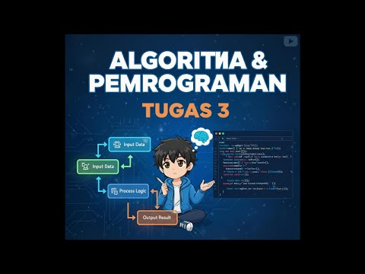

Hasil pengerjaan tugas:
import java.util.Scanner;
public class tugas3 {
public static void main(String[] args) {
Scanner input = new Scanner(System.in);

// deklarasi
double[] arrayGaji = { 5000000, 6500000, 9500000 };
double[] arrayLembur = { 0.30, 0.32, 0.34, 0.36, 0.38 };

String golongan;
int jamLembur;

System.out.print("Masukan golongan (A/B/C): ");
golongan = input.next().toUpperCase();

System.out.print("Masukan jam lembur: ");
jamLembur = input.nextInt();

// gajiPokok
double gajiPokok;

if (golongan.equals("A")) {
gajiPokok = arrayGaji[0];
} else if (golongan.equals("B")) {
gajiPokok = arrayGaji[1];
} else if (golongan.equals("C")) {
gajiPokok = arrayGaji[2];
} else {
System.out.println("Golongan tidak valid");
input.close();
return;
}

// hitungJamLembur
double persenLembur;
double gajiLembur;

if (jamLembur >= 1 && jamLembur <= 4) {
persenLembur = arrayLembur[jamLembur - 1];
} else if (jamLembur >= 5) {
persenLembur = arrayLembur[4];
} else {
System.out.println("Jam lembur tidak valid");
input.close();
return;
}

gajiLembur = gajiPokok * persenLembur * jamLembur;
double totalGaji = gajiPokok + gajiLembur;

// output
System.out.println("\n=== Hasil Perhitungan Gaji ===");
System.out.println("Golongan : " + golongan);
System.out.println("Gaji pokok : Rp " + (long) gajiPokok);
System.out.println("Jam lembur : " + jamLembur + " jam");
System.out.println("Persentase lembur : " + (int) (persenLembur * 100) + "%");
System.out.println("Gaji lembur : Rp " + (long) gajiLembur);
System.out.println("----------------------------------");
System.out.println("Total penghasilan : Rp " + (long) totalGaji);
System.out.println("\n=== Terima Kasih ===");

input.close();

}
}

